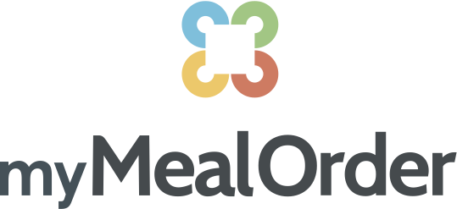
INSTRUCTION INDEX:
Creating an Account & Adding Students Page 2
Ordering, meal details, double orders Page 3
View Cart Page 4
Checkout Page 5
Payment Page 6
View Orders Page 7
Confirmation of Orders Page 8
Cancellation of Orders Page 9
View or Make Changes to Account Page 10
Adding Money to Your Account Page 10
Email Notification Settings Page 11

REGISTRATION & ADDING STUDENTS
CREATE ACCOUNT:
https://mymealorder.com/Login.aspx
Select CREATE ACCOUNT to setup your new account.
Select your State and School. Enter all information as prompted, including Display Name, Address, Phone, Email Address, Username/Password and Security Question/Answer. Press “Click here to add students to your account” when complete.
You will have an opportunity to edit your account in the future if needed. There, you will also find a few options to customize your Account for Email Notifications.
*RECOMMEND LEAVING ALL NOTIFICATIONS ON
ADD STUDENTS:

You will need to add each student attending the school before ordering. Add the students Student Identification number (please contact TRACEY DRANGE to obtain this number)
- Enter students last name as registered in school
- Enter the School student attends
- Select “Add Student”
Repeat this for each student attending this school. Each name will appear in the list at the bottom of the window. You can remove students at any time.

ORDERING
- select your meals for the month in the monthly view
- click meal details for information about a meal
- order a double portion of the main part of the meal by clicking double entrée (double excludes sides)
- submit your order.
- review your cart (update or cancel if needed.)
- *PLEASE NOTE: Orders MUST BE PLACED FOR THE WHOLE MONTH BY THE DUE DATE LISTED!
- TO ORDER:
- • Add to Cart – you can select one day at a time, and that meal for that student will be placed in your Cart.
- • Meal Details – Here you can view information (if there is any) about the menu selections. Simply select any item in the list to open the popup..

TO VIEW CART:

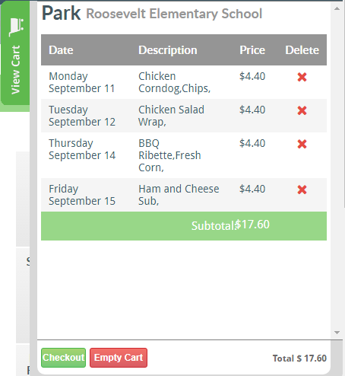

Select from the right‐side of the screen anytime to view items placed in your cart. The Cart will show each menu/item, for each day ordered, by student. The Cart will show the item Ordered, date of the scheduled Menu, Price, Qty, and Description (if any.)
Select next to any item you want to remove from the Cart. You can also close the Cart and remove an order from the Week or Month View.

Select to save and complete your Order and proceed to payment.
Select to empty the Cart and remove all items placed in the Cart.

- FOR CHECKOUT:
From the View Cart window, select

Review your order.
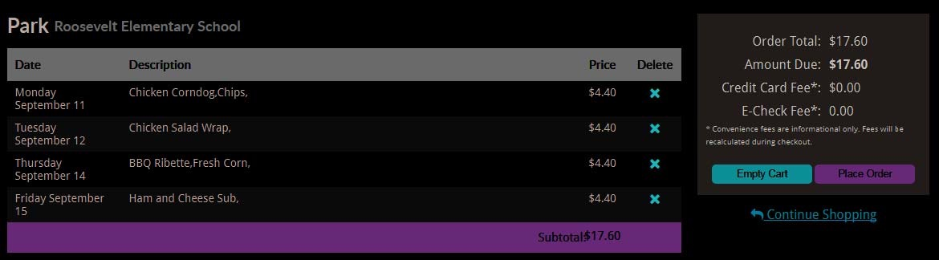

Review: The screen will once again list all items placed in the Cart for Review. The right side of the Review will display the Remaining Account Balance, as well as the Amount Due for this Order.

- COMPLETE YOUR ORDER WITH PAYMENT:
Available Balance: If there is Remaining Account Balance available, the system will deduct the total amount due from your Remaining Account Balance and complete the transaction.
No Available Balance: If the Remaining Account Balance is less than the Amount Due for this Order, selecting Place Order will open the Credit Card Processing Screen to process and complete your Order.

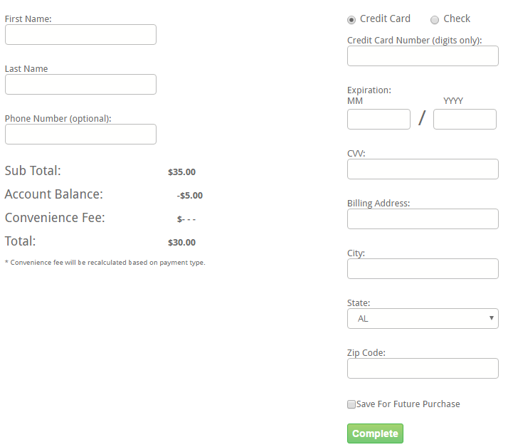

Enter all required information. You can Save your credit card information (optional) to your account, so that future Meal Orders can be charged without prompting your credit card information each time.
Select Complete ‐ to process the order.

TO VIEW ORDERS

- 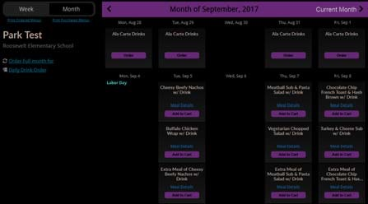
- • Month View – displays meals that are scheduled for each student on the account in a calendar month view. This view allows you to see a month calendar view for all meals that are scheduled for the selected month. Only one student’s scheduled meals are shown at a time. You can use the Student listing dropdown in the upper left portion of the screen, to switch between students.
Week View
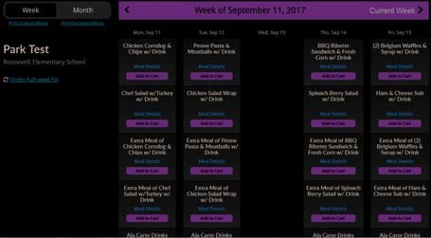

- You may use • Week View – to displays meals that are scheduled for each student on the account in a five‐day (Mon‐Fri) view. This allows you to see all students in the selected week, in one screen.

CONFIRMATION OF ORDERS
Once orders are processed through the Checkout, a confirmation email will be sent to the user. Orders can be viewed in the My Orders Menu Option at the top navigation bar at the top of the screen.
Orders are listed separately for each date, and for each student.
Select Details to view details of the order selected.
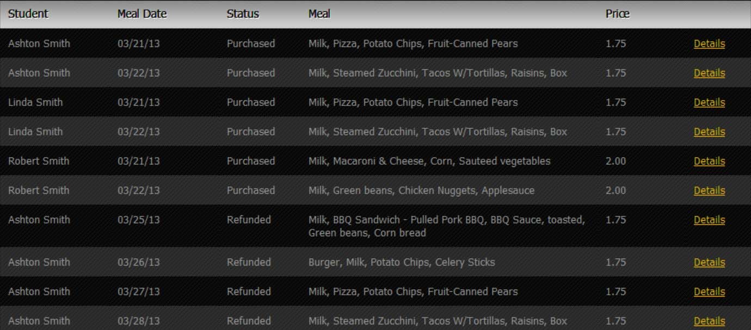
Status

- • Purchased – indicated items have been successfully ordered and payment processed.
- • Refunded – indicates an order has been canceled and the amount refunded to the Account Balance.

- CANCELLING ORDERS
        - Once orders have been purchased, the Add to Cart button changes to an orange button labeled “Purchased: Click to Cancel”. You can cancel an order and be issued a refund by simply clicking this button, *assuming you are within the cutoff time/lead time required. Once cancelled, your mymealorder.com account will be credited the amount of the meal/item cancelled.

- *In the event of absence due to illness, you may receive a refund if you cancel the order by 9am the morning of the missed lunch.

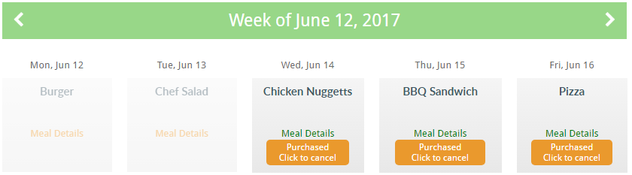

TO VIEW OR MAKE CHANGES TO YOUR ACCOUNT

Select My Account from the top Navigation bar. Here you can Update your:
- • Phone #’s
- • Address
- • Email Address
- • Security Question
- • Add Students
- 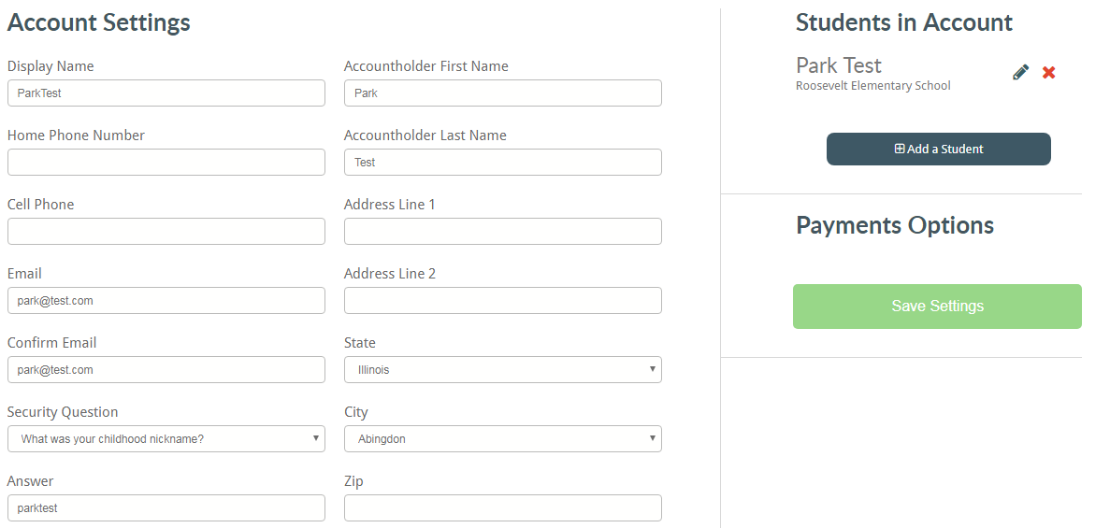
- TO ADD MONEY TO YOUR ACCOUNT
- Select My Account from the top Navigation bar.
- CLICK ADD MONEY TO MY ACCOUNT

EMAIL NOTIFICATION SETTINGS
STRONGLY RECOMMEND LEAVING ALL NOTIFICATIONS ON!

- • Set Email Notification Preferences Email Notifications:
  - • Administration Cancellation – in the event that the District Administration needs to cancel an order, checking this option will suppress any email notifications to you (Default=unchecked – Email Notifications accepted)
  - • Incomplete Order – in the event you add items to the Cart, but do not complete the Order Transaction, checking this option will suppress any email notifications to you (Default= unchecked – Email Notifications accepted)
  - • Order Receipt – in the event you complete a purchase, checking this option will suppress the email receipt notification. (Default= unchecked – Email Notifications accepted)
  - • Opt Out of all Notifications – checking this option will suppress ALL email notifications to you (Default= unchecked – Email Notifications accepted)
